**Restaurant Database Management**

# Project OWNER

|  |  |  |
| --- | --- | --- |
| **No** | Stu-Number | Name Surname |
| 1 | 17070001029 | Işık Alioğlu |
| 2 | 17070001017 | Yağmur Alioğlu |
| 3 | 16070001026 | Can Hatipoğlu |

**PHASE 4- USER INTERFACE**

# Graphical User Interface

Prepare a front-end program to display database modifications, Can be desktop, mobile native or web based, Put your GUI snaphot below and explain.

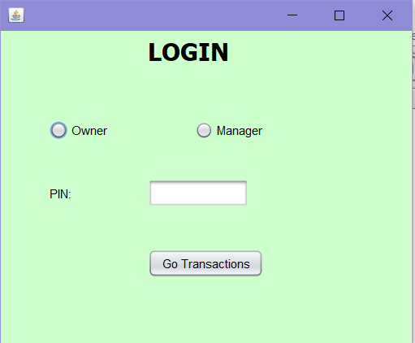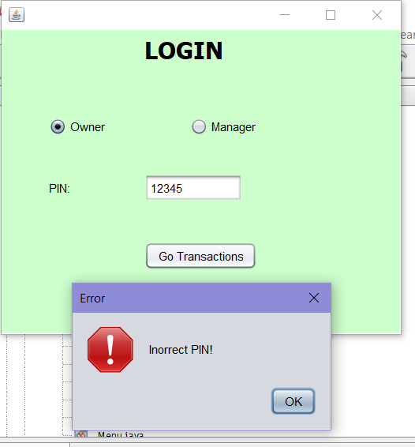

We have 2 user to reach, insert,delete the database information of restaurant . Owners pin is originally 1234. If the pin is incorrect, there is error message.

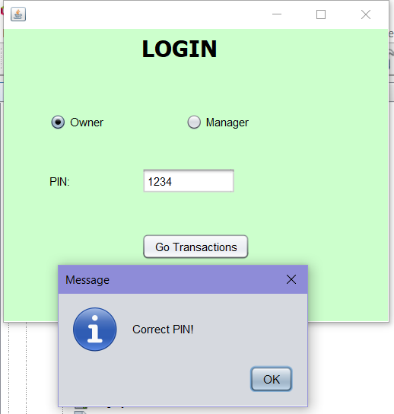

Now , if it is correct pin so allow to login the database to do transactions.

metin içeren bir resim

Açıklama otomatik olarak oluşturuldu

This is transactions screen to select the required transactions. Lets choose Waiter information.

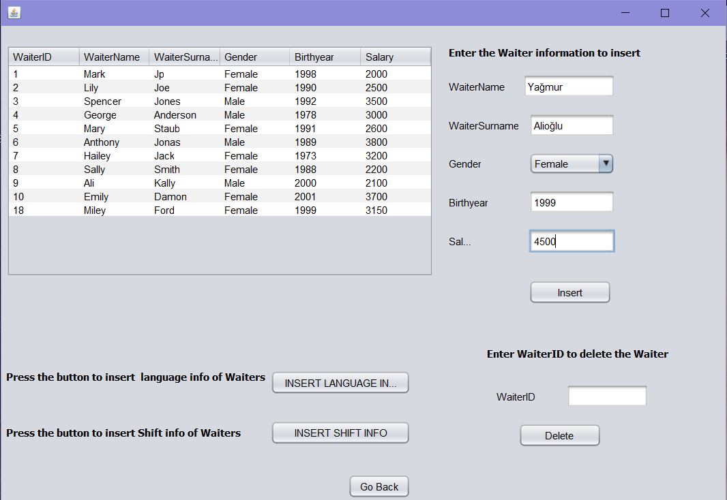

We enter the new waiter’s infos to insert waiter table. When we press the insert button. We can see the new waiter in the table

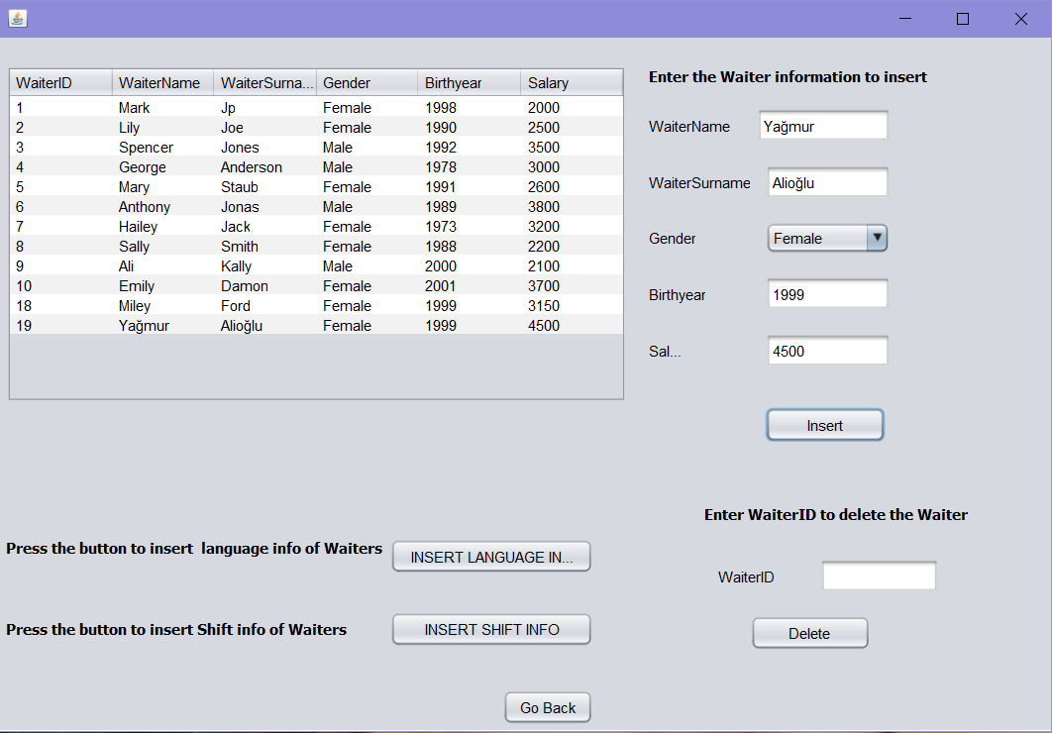

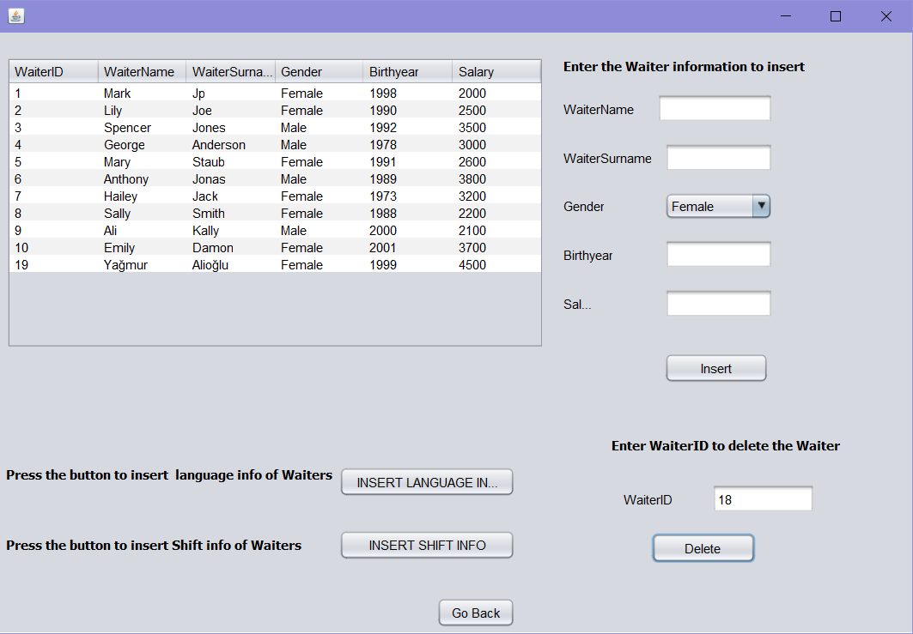

We entered the waiter id that we want to delete in the table. We choose the 18. Waiter to delete. And it deleted from the table.

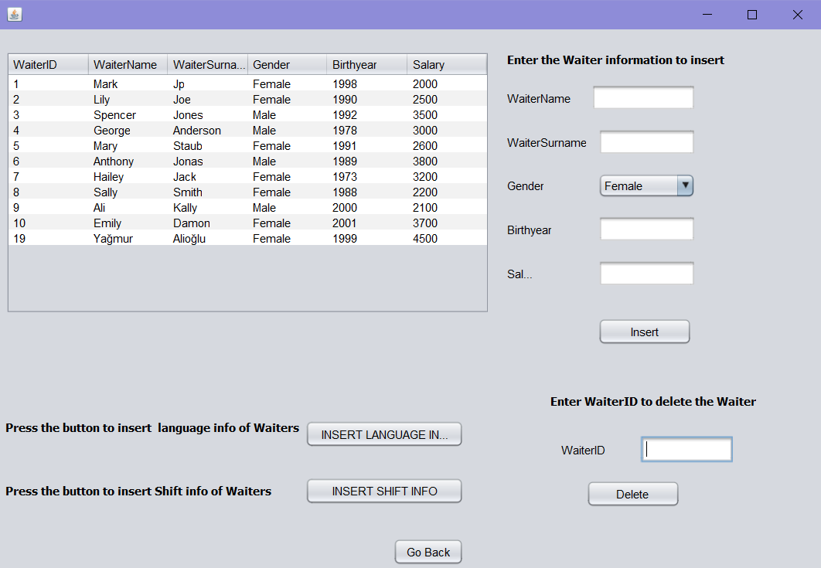

Let press the INSERT LANGUAGE button to add or update the language relations of Waiters.

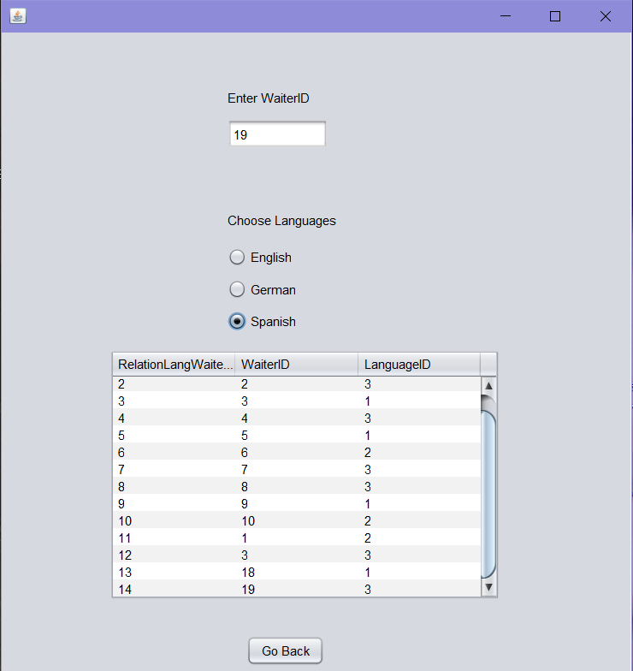

We choose the Waiter that have 19 id number and we add spanish which id is 3 for this waiter.



When we press the go back button waiter informations screen is available an we press insert shift info button.

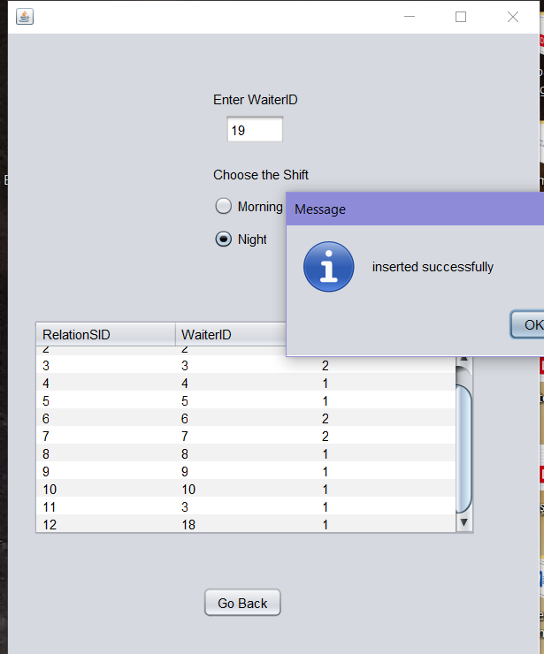

We entered the waiter id as 19 and chose the Night shift for this waiter. Information message came.

tablo içeren bir resim

Açıklama otomatik olarak oluşturuldu

We went back to transactions screen by pressing the go back buttons.

metin içeren bir resim

Açıklama otomatik olarak oluşturuldu

Customer table .When we press the insert button we can see the Ben in the table.

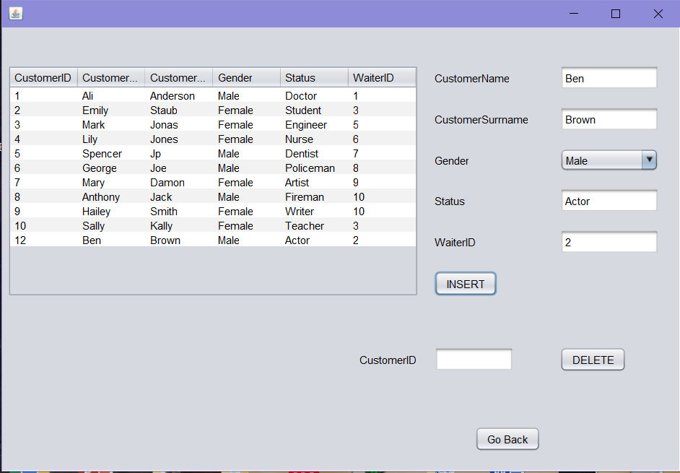

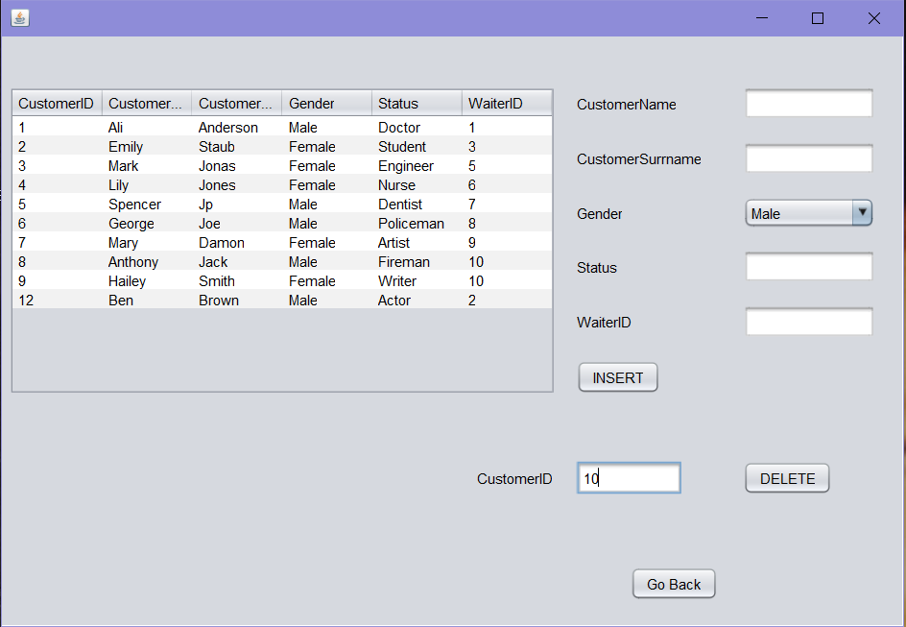

We entered Waiter id as 10 in the delete side of the screen and press the delete button. We can see the table without Sally who has id number 10.

We press the Go back button to go to Transactions screen.

metin içeren bir resim

Açıklama otomatik olarak oluşturuldu

Before we insert the new Chef infos.

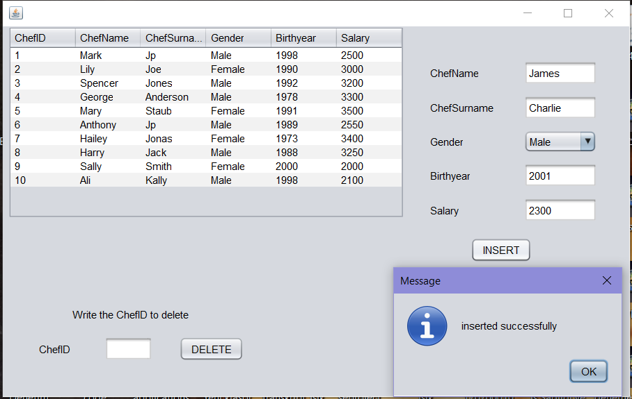

After we add the James as new Chef in the table.

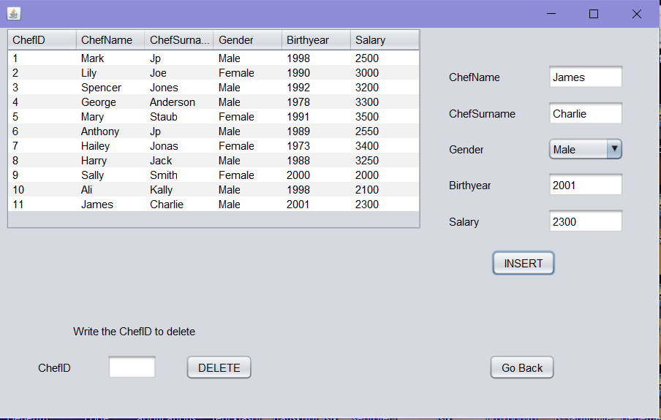

We entered the chef id to delete from table. Chef who has 11 chef id is deleted successfully.

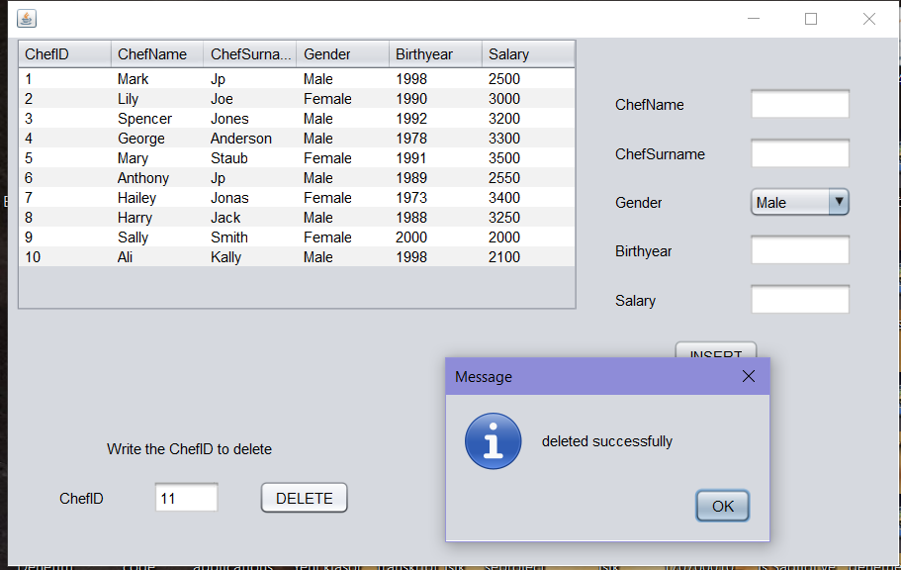

When we press the Go back button ,Transactions screen is available again.

metin içeren bir resim

Açıklama otomatik olarak oluşturuldu

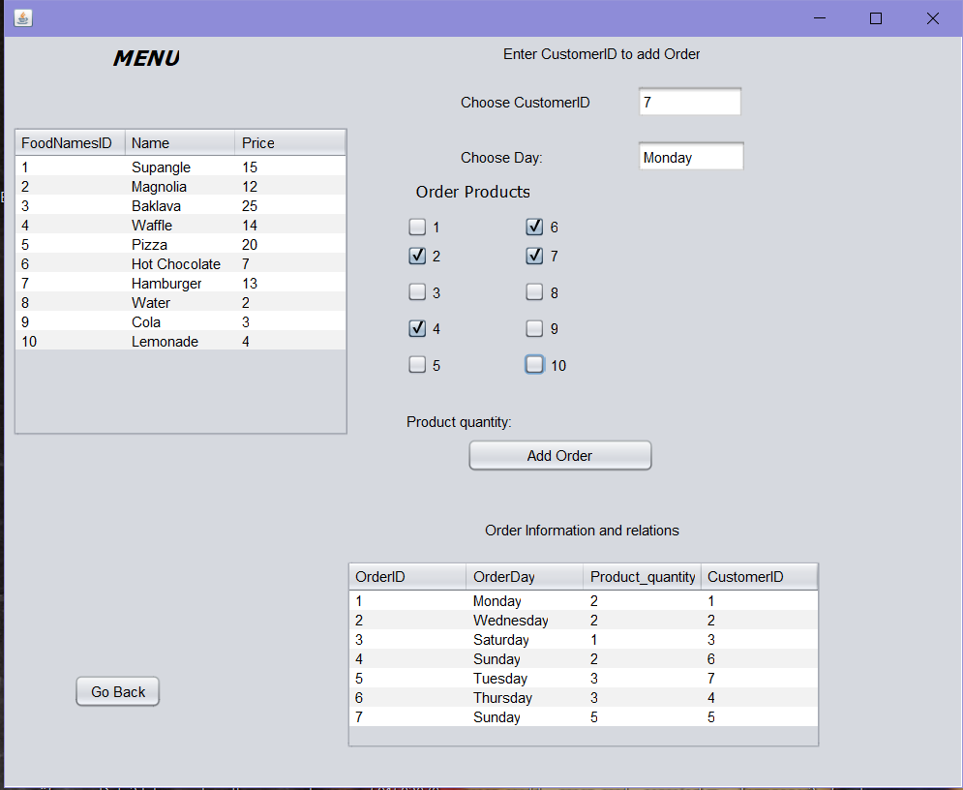

We have menu to show food and beverage infos. When we entered Customer id ,order day and choose order product to calculate order’s product quantity. Also we have other table to show Order information and relation with Customer who gave the order. As an ex: Customer 7 gave an order on Monday that include products that have 2, 4, 6, 7 ids. When we press add order button, we will see the new releation row in the next step.

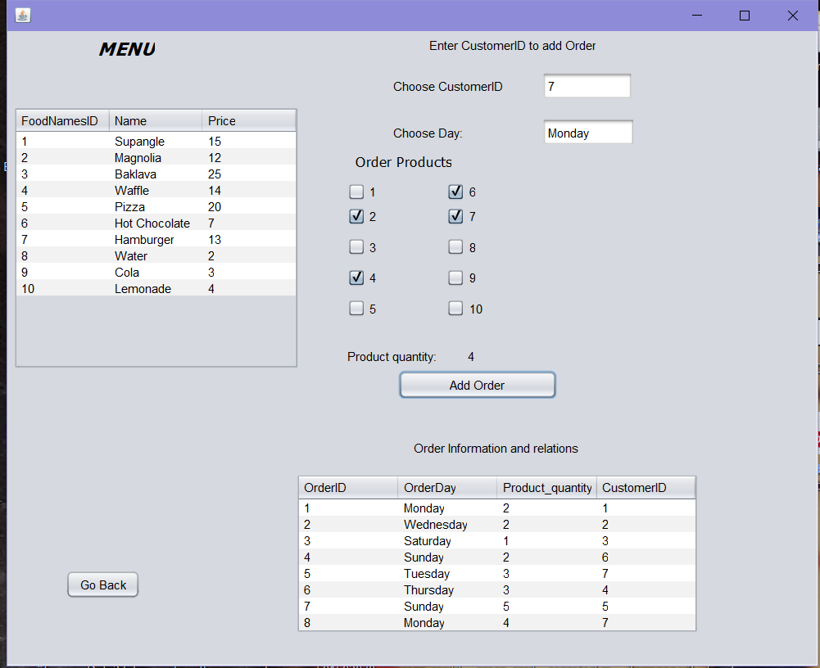

When we press the go back button we will see the transactions screen.

metin içeren bir resim

Açıklama otomatik olarak oluşturuldu

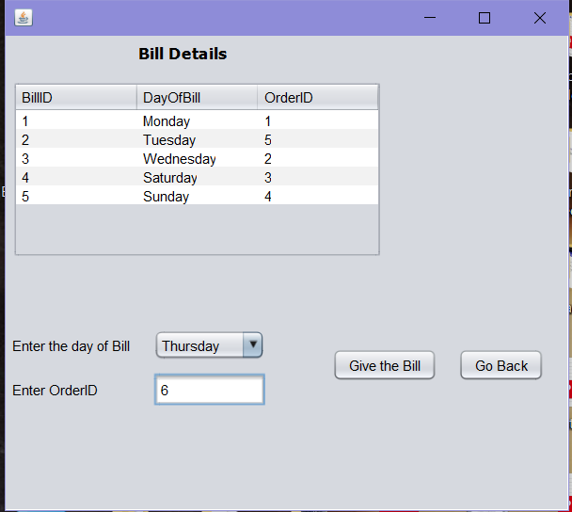

Bill Details table before we were not added new Order infos. Giving new bill we choose Thursday and Order id 6. We can see the new relation in the table in the next step.

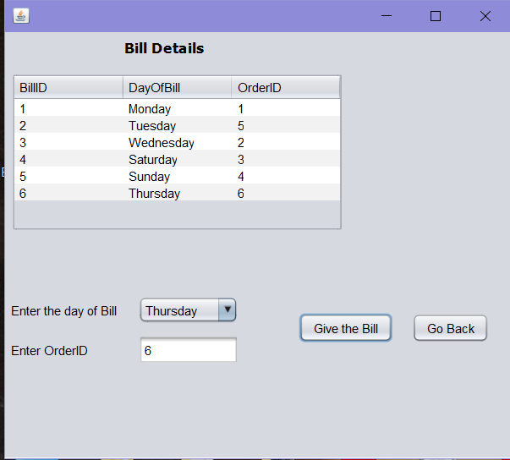

# Discussion and self-evaluation

Write a paragraph to evaluate this project study. List some proposals to make it happen better.

Our project is about restaurant database management. Before starting the project, we shared our own ideas, so we combined all these ideas that are about content of tables, required attributes and their constraints and relation of these tables.

In Phase1 we applied all of these steps and created a database. After that, we applied Normalization rules that we learned in our theoretical lessons, so we revealed last version of our database in Phase2 and it provides us to learn how to apply normalization in real life examples. Also, we added sql examples to make it clear. In Phase3, we give more examples which is about triggers,assertions,join,alter, etc. to show our ability of mysql usage. We share our examples each other and chose the perfect ones to put our Phase3 file.

Lastly, we created a front-end program by connecting Mysql with netbeans. It showed us , learning database and mysql make creating user interface program easier and more effective. Last year we tried to make front end program by using text files, it was really harder than this method.

This project showed us manage the database effectively according to customer desired. And it makes keeping the data correctly and connecting other applications easier. Also, it was really good practice to apply all theoretical topics to the real life examples.

Adding more tables, creating our user interface’s apperance more attractive made our project better.